Fandisk with different resolutions

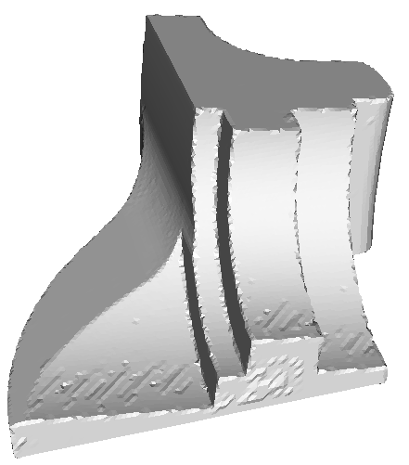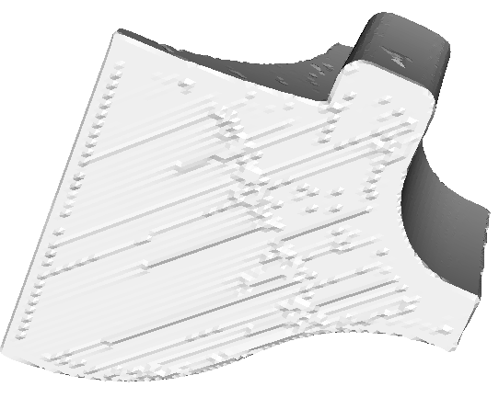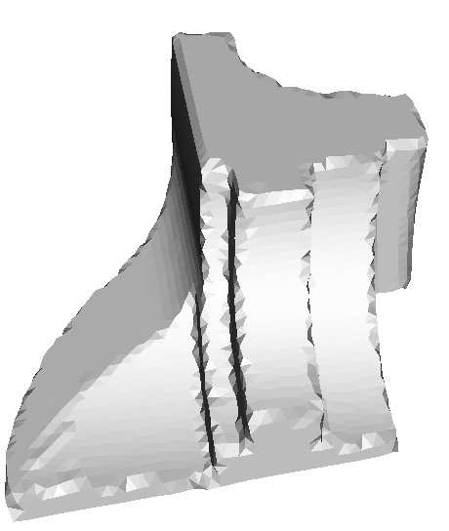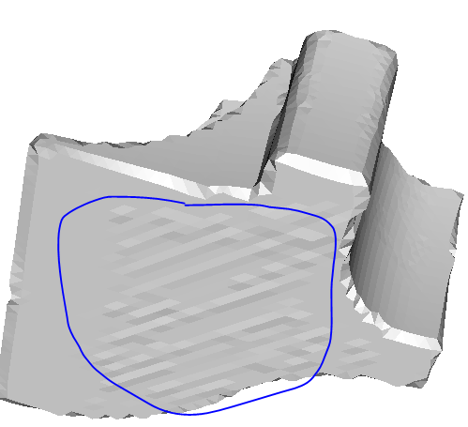
Result of dense resolution (20545 vertices) Result of coarse resolution (3724 vertices)
Conclusions:
The coarse non-obtuse cannot enlarge the feasible region too much. As we know, the edge of non-obtuse mesh is larger on a coarse resolution, but the error to the original mesh is also larger as shown in the followed figure.
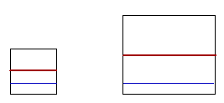
The blue line is the original one, and the red line is the non-obtuse one (mid-point).

